Creating a Student Business Card with the University Logo

- Ask Career Services for a Business Card template. We will send you two Microsoft Publisher files via email (see templates below).
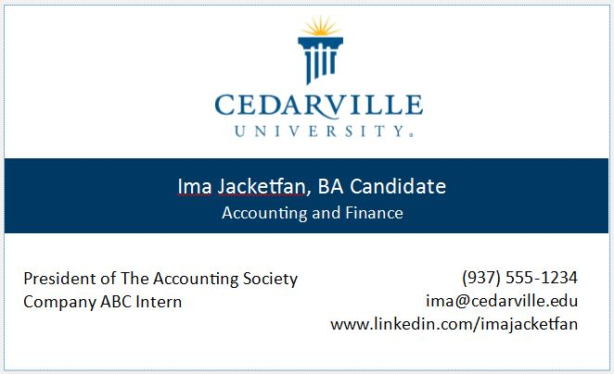
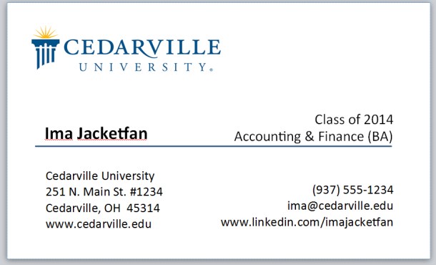

- Choose one of the templates and edit it in Microsoft Publisher. Publisher is available on any campus computer.

IMPORTANT NOTES:
- To use these cards with the CU logo, you MUST include an element that indicates you are a student! Examples: Accounting & Finance (BA), Class of 2015, etc. If you do not include these, it can indicate that you are an employee of CU, not a student, and that isn’t in concordance with CU logo regulations.
- Do not stretch or pull the logo graphic out of proportion. "Place your cursor on one of the four corners of the logo and hold down shift as you adjust the size. This will ensure the logo stays in the correct proportion.

- Save the Microsoft Publisher document as a PDF when finished and send it to Print Services, or upload the PDF to an online printing service such as www.vistaprint.com . When using the logo, you must use white paper only – no other colors. You always have the option of creating your own business card without the Cedarville logo.

